**BLUEPRINT**

* Ideas
  + Tabletop
    - An octagon
  + Exchangeable tops
    - Chessboard
      * Board itself
        + Colors of the board itself

Blue

Red

* + - * + How it comes together
      * Pieces design overview
        + Pawn
        + Rook
        + Knight
        + Bishop
        + Queen
        + King
    - Grill top
      * What is it out of
        + Expanded metal

In a lattice pattern

* + - * + A cool design on top, for style

Out of sheet metal,

Probably 11ga, or 14ga,

Most likely 14ga

* + - Open
      * No description necessary
    - Cutting board
      * Out of probably fancy stone
        + Hard, but light,

Easy to store/use

* + - Closed, no fire
      * Regular cap
        + Cool design on top,

Very fancy handle

* + - How to remove them
      * Unknown at this current hour
  + Legs
    - Straight square tubing down in a square.
      * A

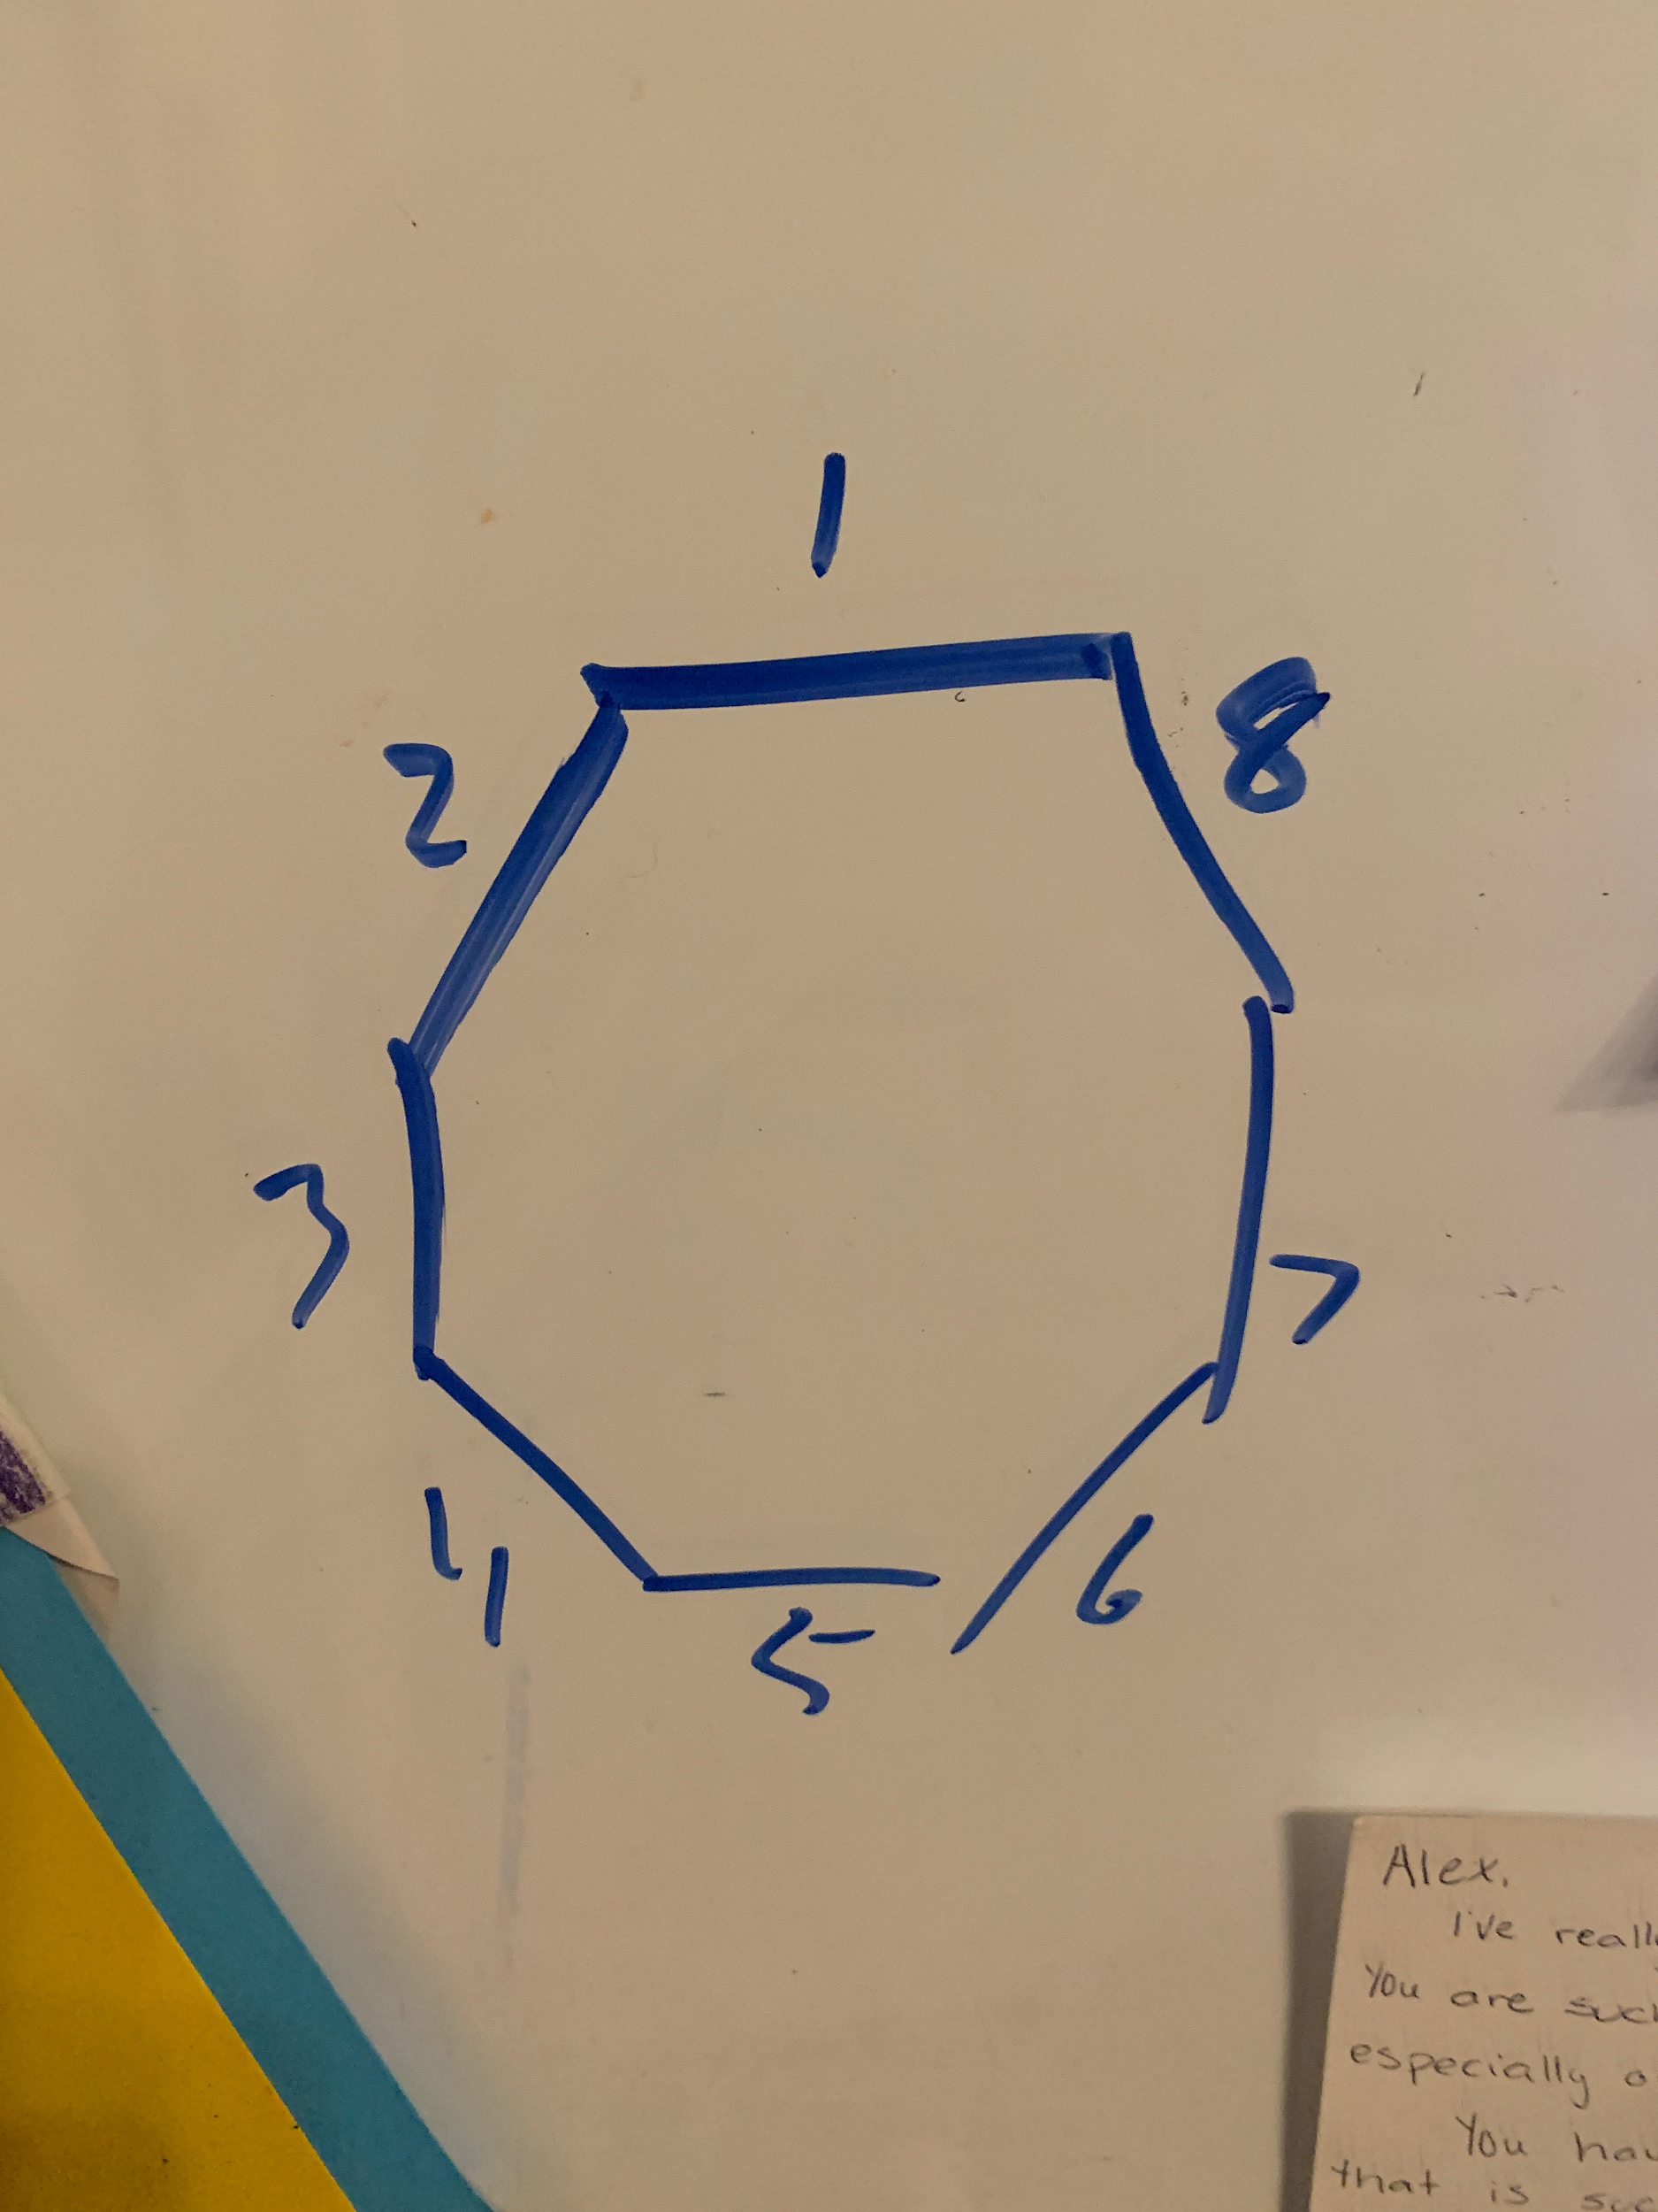 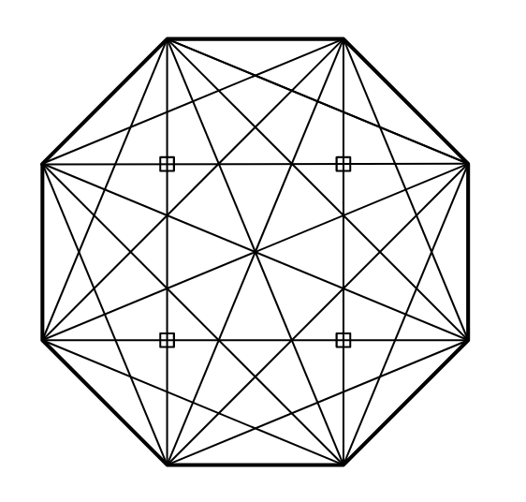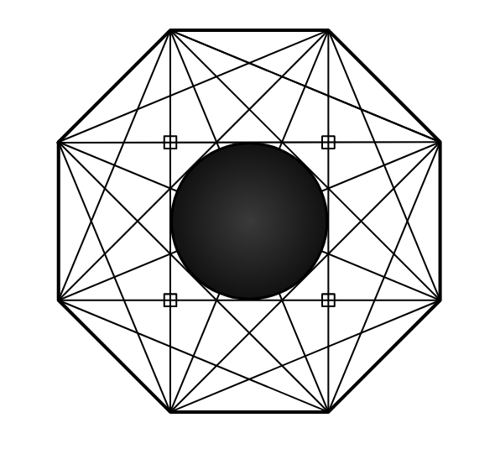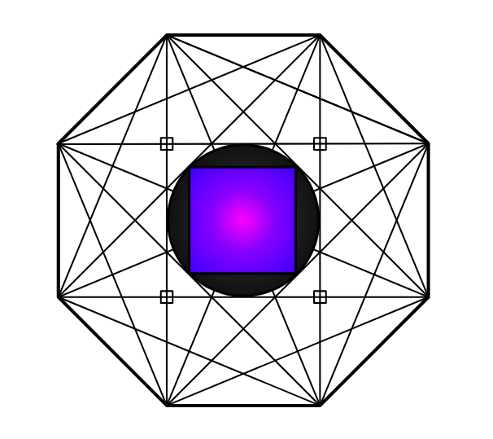

The purple +black is the tops for the dome

The purple is specifically for the chess board

The rest of the black, is the generic custom fits,